**Database Management of Pharmacy Systems**

# G Sai Krishna

# **Pangoth Santhosh Kumar**

# **Meetiksha Sorgile**

__________________________________________________________________________

**ABSTRACT**

In recent years, technology has played an important role in all areas of management to computerize most information. People work in an efficient way. Paper-based service management also faces a number of challenges. Labor-intensive accessibility, complexity in specific areas that can be generalized to management . In addition to finding qualified employees who can meet the needs and expectations of employers, that is, most of the time is spent tracking, matching or saving documents in manual mode. Pharmacology is the branch of biology that deals with the study of the properties of chemicals and is interested in the study of the use, action, and side effects of drugs. One of the promising strategies in medicine is health information technology, which is used to minimize many types of medical errors. The most common technologies are barcode verification, electronic prescription technology, and computer-assisted order entry (CPOE). A pharmacy system is considered a computer system used for administration and storage. Medicines at the pharmacy. These systems have replaced manual systems with high-performance features such as inventory management and control, drug labeling, knowledge of a patient's drug history, and support for hospital pharmacy processes. In this study, we presented an electronic pharmacy management system based on an embedded serverless database engine and a GUI frame developed for multiple users with various purposes. Embedded patient and medication information as well as inpatient and outpatient information are stored in an embedded database. The presented system is divided into patient registration, pharmacist, drug (after expiration date), physician, and registrar. Each part above contains different types of operations and database tables in addition to its own GUI frame for administration.

# Table of Contents

**Title Page No.**

**ABSTRACT…………………………………………………………. i**

**TABLE OF CONTENTS………………………………………....... ii**

**LIST OF FIGURES………………………………………………….. iii**

**LIST OF TABLES……………………………………………….... iv**

**CHAPTER 1 INTRODUCTION 1**

1.1 Section 1.1………………………………………………………………. 1

1.2 Section 1.2………………………………………………………………. 2

**CHAPTER 2 LITERATURE REVIEW 3**

2.1. Section 2.1………………………………………………………………. 3

2.1.1. Sub Section 2.1.1………………………………………………… 6

2.1.2. Sub Section 2.1.2………………………………………………… 7 2.2. Section 2.2………………………………………………………………. 8

**CHAPTER 3 PROPOSED SOLUTION 10**

3.1. Section 3.1………………………………………………………………. 10 3.2. Section 3.2………………………………………………………………. 11

## CHAPTER 4 RESULTS 11

4.1. Section 4.1………………………………………………………………. 12

4.2. Section 4.2………………………………………………………………. 13

## CHAPTER 5 CONCLUSIONS 14

5.1. Section 5.1………………………………………………………………. 14

5.2. Section 5.2………………………………………………………………. 17

**List of All Figures**

| **Figure No** | **Figure Title** | **Page Number** |
| --- | --- | --- |
| **1** | **ER modelling for proposed database system** | **9** |
| **2** | **UML modelling for proposed database system** | **10** |
| **3** | **Authentication Page in proposed web application** | **13** |
| **4** | **Home Page Dashboard for the administrator** | **14** |
| **5** | **Inserting the details of Pharmacists with their credentials** | **14** |
| **6** | **Managing the stocks of the drugs with their expirations** | **15** |
| **7** | **Managing the Personal Accounts** | **15** |
| **8** | **Dispensing the drugs to patient by pharmacists** | **16** |
| **9** | **Managing the records of dispenses given to the patient** | **16** |
| **10** | **Feedback chat between the patient and the pharmacist** | **17** |
| **11** | **Functionalities of the patient, doctor and clerk respectively** | **17** |

**List of All Tables**

| **Table No** | **Table Title** | **Page No** |
| --- | --- | --- |
| **I** | **Admin data and its properties** | **11** |
| **II** | **Pharmacists data and its properties** | **11** |
| **III** | **Patients data and its properties** | **12** |
| **IV** | **Doctors data and its properties** | **12** |
| **V** | **Pharmacy Clerk data and its properties** | **12** |

**Introduction :**

Traditional pharmacy data management systems are plagued by capacity, time, and drug availability. The need for qualified personnel to manage the drug warehouse and meet the requirements of the employer's expectations. Even though the pharmacy doesn't look much different from other stores, the way it works. There are many laws governing the operation of pharmacies. Therefore, building a pharmacy database management system requires investigating how things are handled in terms of managers, patients, pharmacists, receptionists, doctors. The proposed project is an end to end implementation of Pharmacy DBMS which is divided into two main parts: the database created using the SQLite3 serverless database engine and the Graphical user interface (GUI) programmed using Python Django. Databases contain relevant pharmacy information related to medicines, patients, etc. The GUI facilitates the use of the proposed system by unskilled users with user-friendly functionalities.. The system has five types of users: administrator, pharmacist, doctor, receptionist (pharmacist), and patient. Each user has different functionalities and login credentials based on their position. The proposal system is responsible for overseeing and managing the operations of the pharmacy in the hospital from a management and safety perspective.

**Motivation :**

As part of India's national health reform, rapid advances in computer communication technology have significantly changed the way hospitals process health information. Many hospitals implement HIS (Hospital Information System) to store, host, and manage large amounts of medical information using computers, and CPMS (Clinical Pharmacy Management System) is a major part of HIS. Currently, hospitals CPMS is focused on drug inventory, sales and storage, i.e. the assurance of drug supply including logistics and cash flow. This system has transitioned from manual accounting to computer accounting. However, the focus of pharmacists in hospitals is increasingly shifting towards patient-centered drug management. Currently, HIS does not include a function to provide drug information to clinical pharmacists, so it must be supplemented through advanced computer software. Most pharmacy management systems are drug management inclined, so there should be a CPMS that can adapt the needs of patients, pharmacists, and physicians.

**Need of Project Models :**

Prior to the era of computer integration, paper-based solutions were used as inventory management tools. If automated systems are not available, these solutions can create a lot of paperwork and are often error-prone as the workload increases as more than hundreds of drugs are processed. The pharmacy management system is designed to ensure efficient and clear storage and processing of data and careful handling of pharmacy medicines. The pharmacy management system will save you a lot of time and resources and allow you to retrieve data as quickly as possible through the drug data search. Also, most of the resources are fully utilized because most operations are done in the pharmacy system. Minimized resources include paper, workforce, and related items.

However, hospital pharmacists are increasingly focusing on patient-centric drug delivery. Currently, SIS does not include the ability to provide drug information to clinical pharmacists. To achieve business goals through the adoption of computerized systems, the world needs to adopt new technology to track all transactions and daily activities. It is possible to design and implement such a system, but it requires preliminary work on the computation with the pharmacy laws. Investigate the operational environment and pharmacy needs to identify the needs of patients, physicians, software identification tools, and system databases. Design and develop user interface applications. Therefore, some changes need to be made to the current system to meet the needs of each year. For the all above challenges and enhancements, the model we propose is essential.

**Problem Objectives :**

The main goal of this project is to allow a pharmacy's management administration and staff to grip patients and doctors in order to make dispenses and identify available prescriptions based on the number of drugs they require and stocks. Our web application will allow patients to check their dispenses and chat with the pharmacists. The overall goal of our program is to provide a pharmacy management system that will aid pharmacists in resolving basic concerns with their manual billing and writing method, such as time, cash, and vulnerability.

The proposed system should achieve the following goals:

1. The website must have different authentication and interfaces for different users based on their designations and functionalities
2. Add or update the stock of medicines categorizing with their scientific names, manufacturing company, manufacturing and expiry dates.
3. Generate dispenses reports which are generated by pharmacists and can be viewed by patients.
4. Detects expired drugs which need to be disposed of .
5. Improve system efficiency by effectively monitoring services and activities. E
6. Ensure optimal management of drug stocks by monitoring drug movement within the pharmacy.
7. Make sure the system is user-friendly.
8. It must be possible to generate reports for each and every detail.

**Contributions :**

Our project solves the above-discussed problem in an easy and efficient manner and also helps the pharmacy to keep records of their patients, doctors, and drugs. Hence our project benefits both the patients as well as pharmacists in their respective use. With the help of this project, we are also saving time, energy as well as paper by providing the dispenses, admissions, expiration which can be displayed in the application and the patients can also give feedback of drugs after use to the pharmacists. So, in this way, our system is contributing towards society's requirements and pharmacy demands.

**Proposed Model:**

The proposed system comprises into sub-categories as follows:

* Requirements gathering and analysis
* Conceptual database design
* Implementation of the database system in web application

**Requirements gathering and analysis :**

During this phase, we met with potential users like patients, doctors, pharmacists of the pharmacy system to understand and document their data requirements. The result of this step is a concise set of different user’s requirements. Knowing the requirements of your system is critical to the success of your system. Collect, modify and analyze critical inventory details, including dispenses details, user’s records, drug records.

**Conceptual database design :**

The next step is to create a conceptual database schema using a higher level. Concept diagrams are descriptions of user requirements for data. These concepts are generally easy to understand as they do not contain implementation details. It can be used to communicate with non-technical users. Concept diagrams can also be used as a reference to ensure that all requirements are met and there are no conflicts. In this project, conceptual modeling is performed using both ER modelling and Unified Modeling Language (UML) class diagrams as represented in Fig. 1 and Fig. 2 .

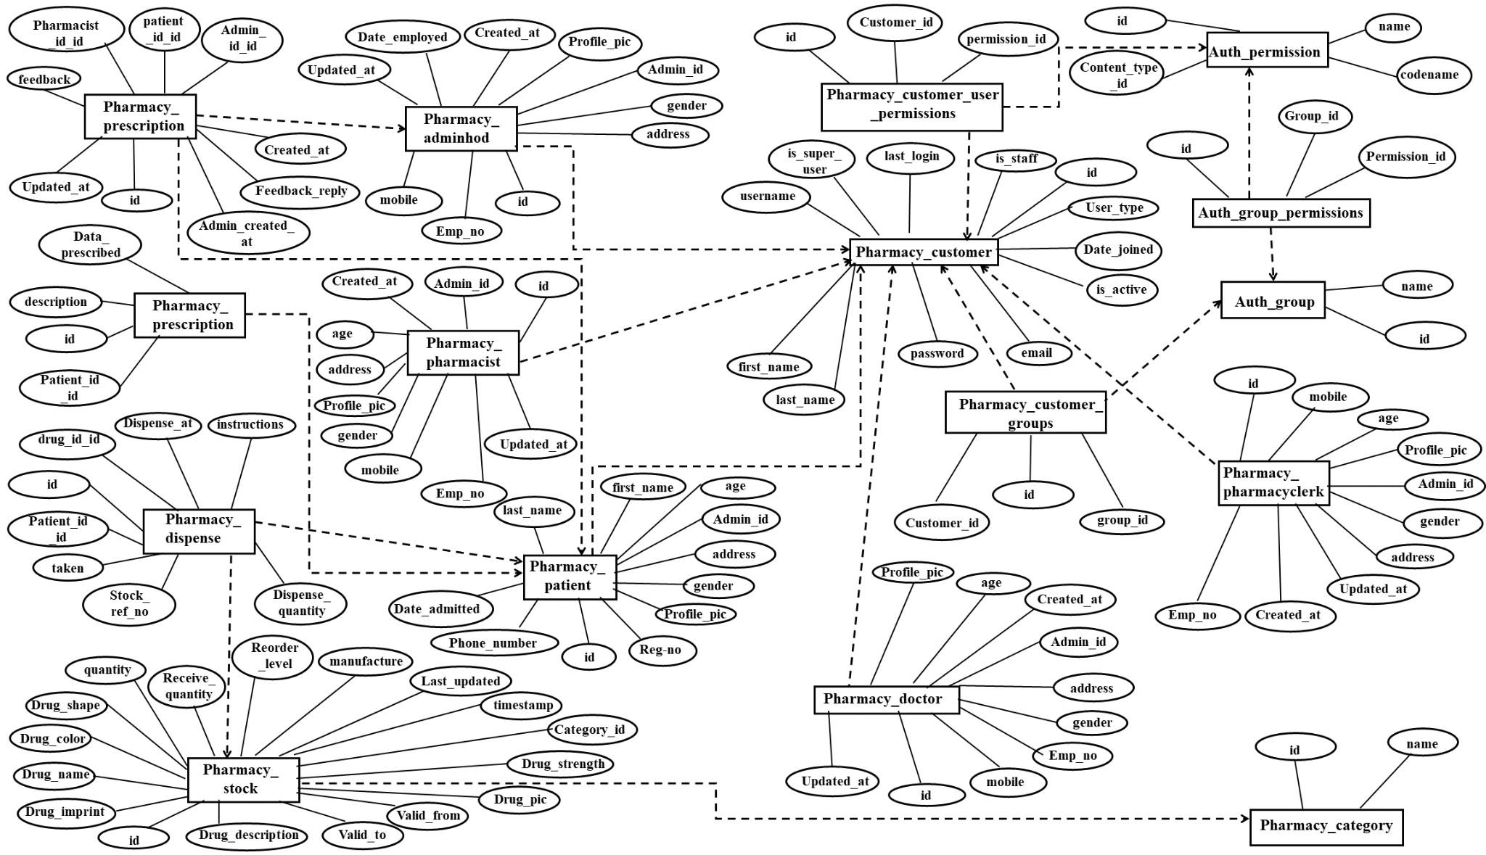

Fig. 1 ER modelling for proposed database system

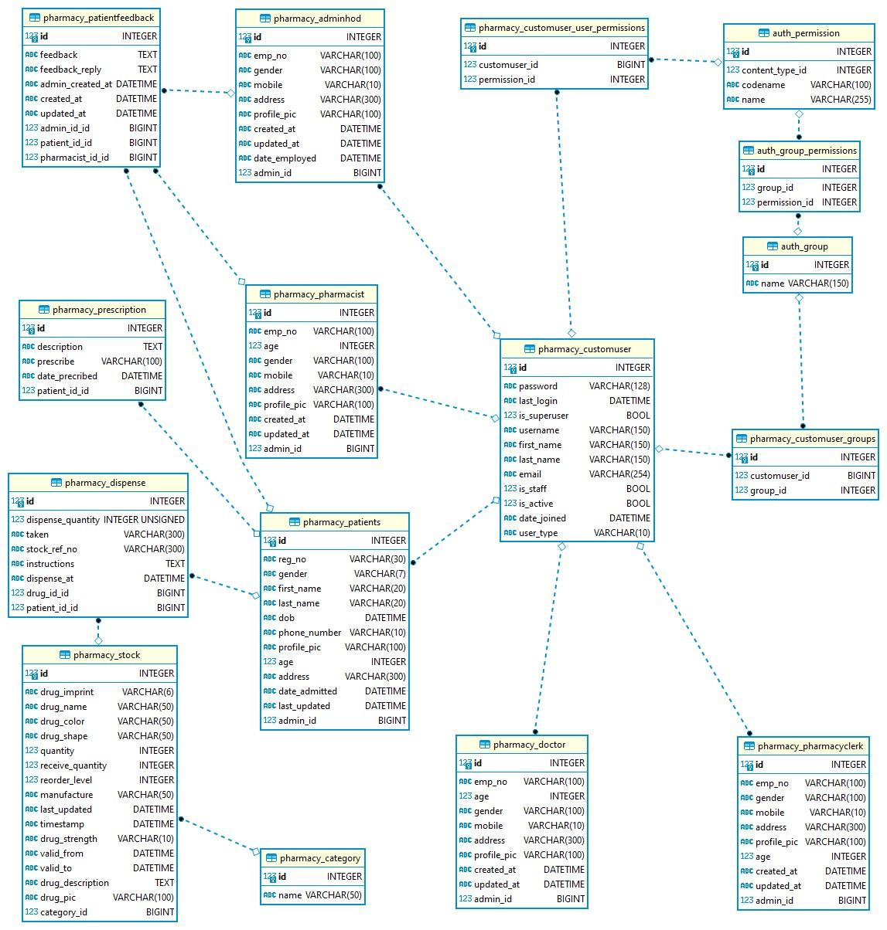

Fig. 2 UML modelling for proposed database system **Implementation of the database system in web application :**

The implementation of database is via five different user interfaces for different users and their designations and functionalities

**Admin :** The functionalities of admin includes :

* All System User Management
* Patient prescription management
* Drug Category Management
* Drug management
* Stock management
* Personal account Management

The table for admin data:

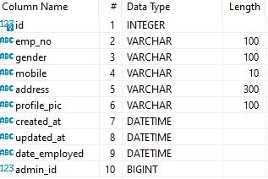

Table I : Admin data and its properties

**Pharmacists :** The functionalities of pharmacists includes :

* Drug management
* Stock management
* Release the drug
* Reply patient feedback messages
* Personal account management

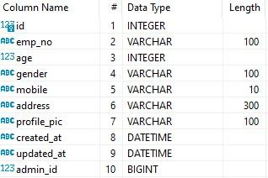

Table II : Pharmacists data and its properties

**Patients :** The functionalities of patients includes :

* View their dispenses and instructions
* Feedback to the pharmacist in case of dispensing problems

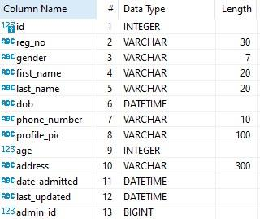

Table III : Patients data and its properties

**Doctors :** The functionalities of doctors includes :

* Admissions/Patients Management

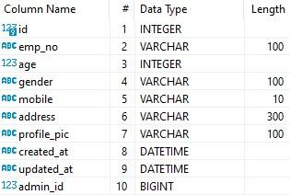

Table IV : Doctors data and its properties

**Pharmacy Clerk :** The functionalities of pharmacy clerk includes :

* Prescription Management

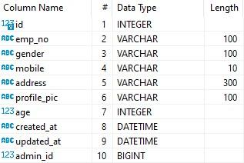

Table V : Pharmacy Clerk data and its properties

In this phase, databases and applications are deployed for deployment, testing, and maintenance. Test the different apps individually and then test them together. This opens up opportunities for physical design changes and reconfiguration, an activity commonly referred to as database tuning that continues throughout the life of a database as databases and applications continue to evolve and performance issues are discovered.

**Results :**

The Visual Studio Code (VS) environment is operated to develop and implement the graphical interface of the proposed system by integrating it with a serverless SQLite3 environment.

The authentication page of the web application is shown in Fig. 3

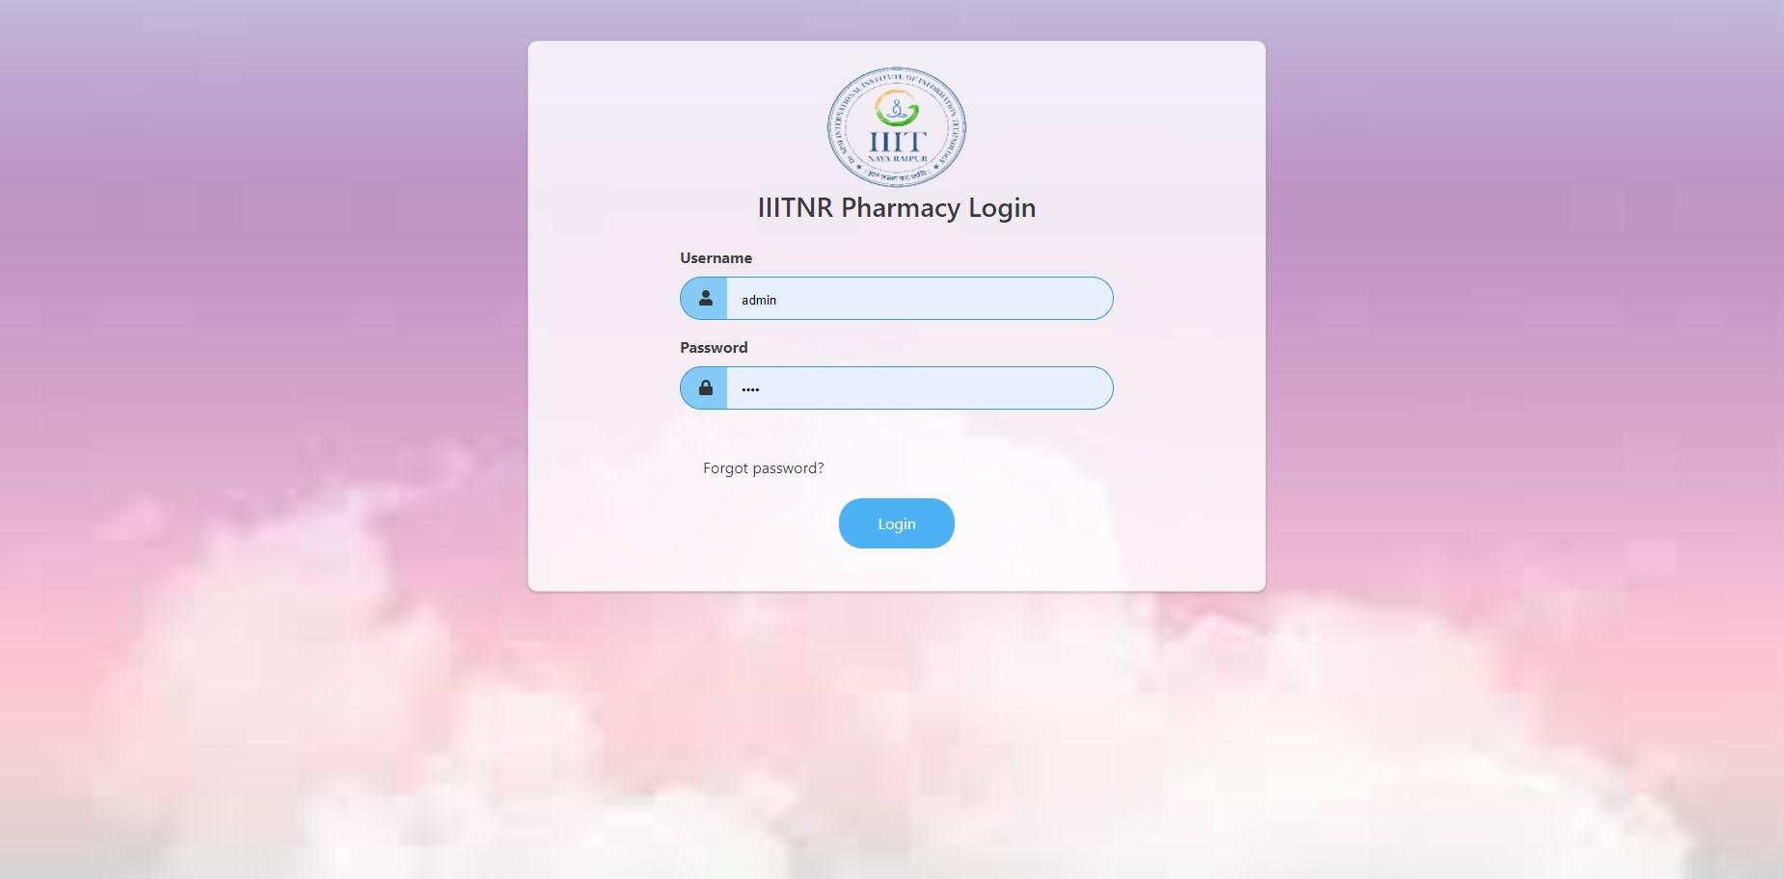

Fig. 3 Authentication Page in proposed web application

The credentials for the administrator, pharmacist, clerk, doctor, patient are unique and can be managed by the administrator. The dashboard and the primary interface for the administrator is shown in Fig. 4.

The home page of the admin involves actions that are concerned with registration of patient, pharmacist, doctor, and clerk and update their information, creation and managing the medicines issuing to the categories, the medicines issuing to the patients and managing the stored medicines.

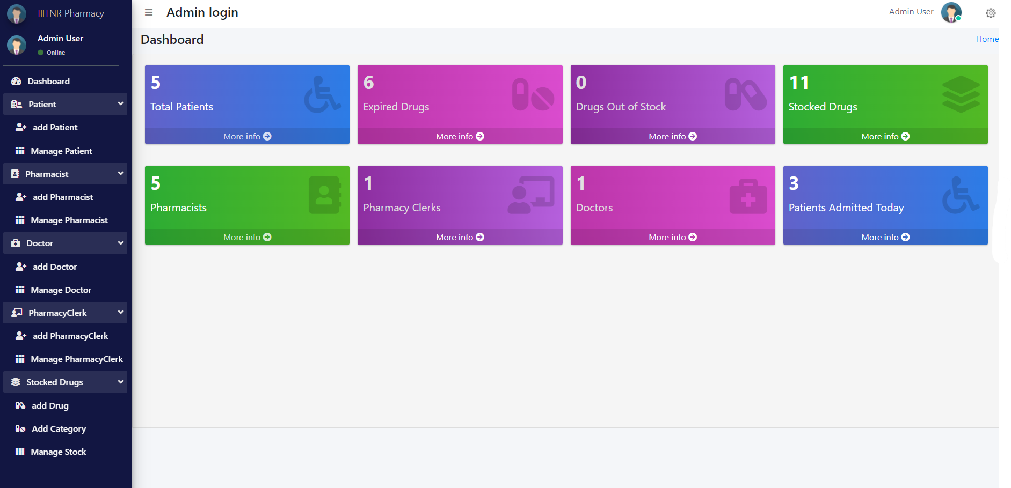

Fig. 4 Home Page Dashboard for the administrator

There are multiple functionalities like registration of the different users and managing and creation of drugs by the administrator. Few of the examples for adding the pharmacists with their authentication and managing the stocks of drugs are shown in Fig. 5 and Fig;. 6

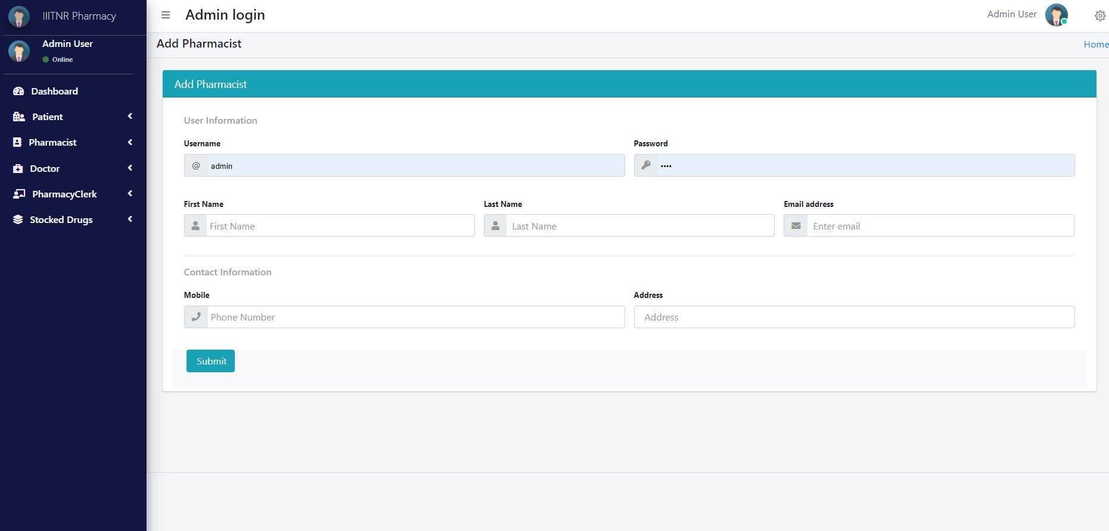

Fig. 5 Inserting the details of Pharmacists with their credentials

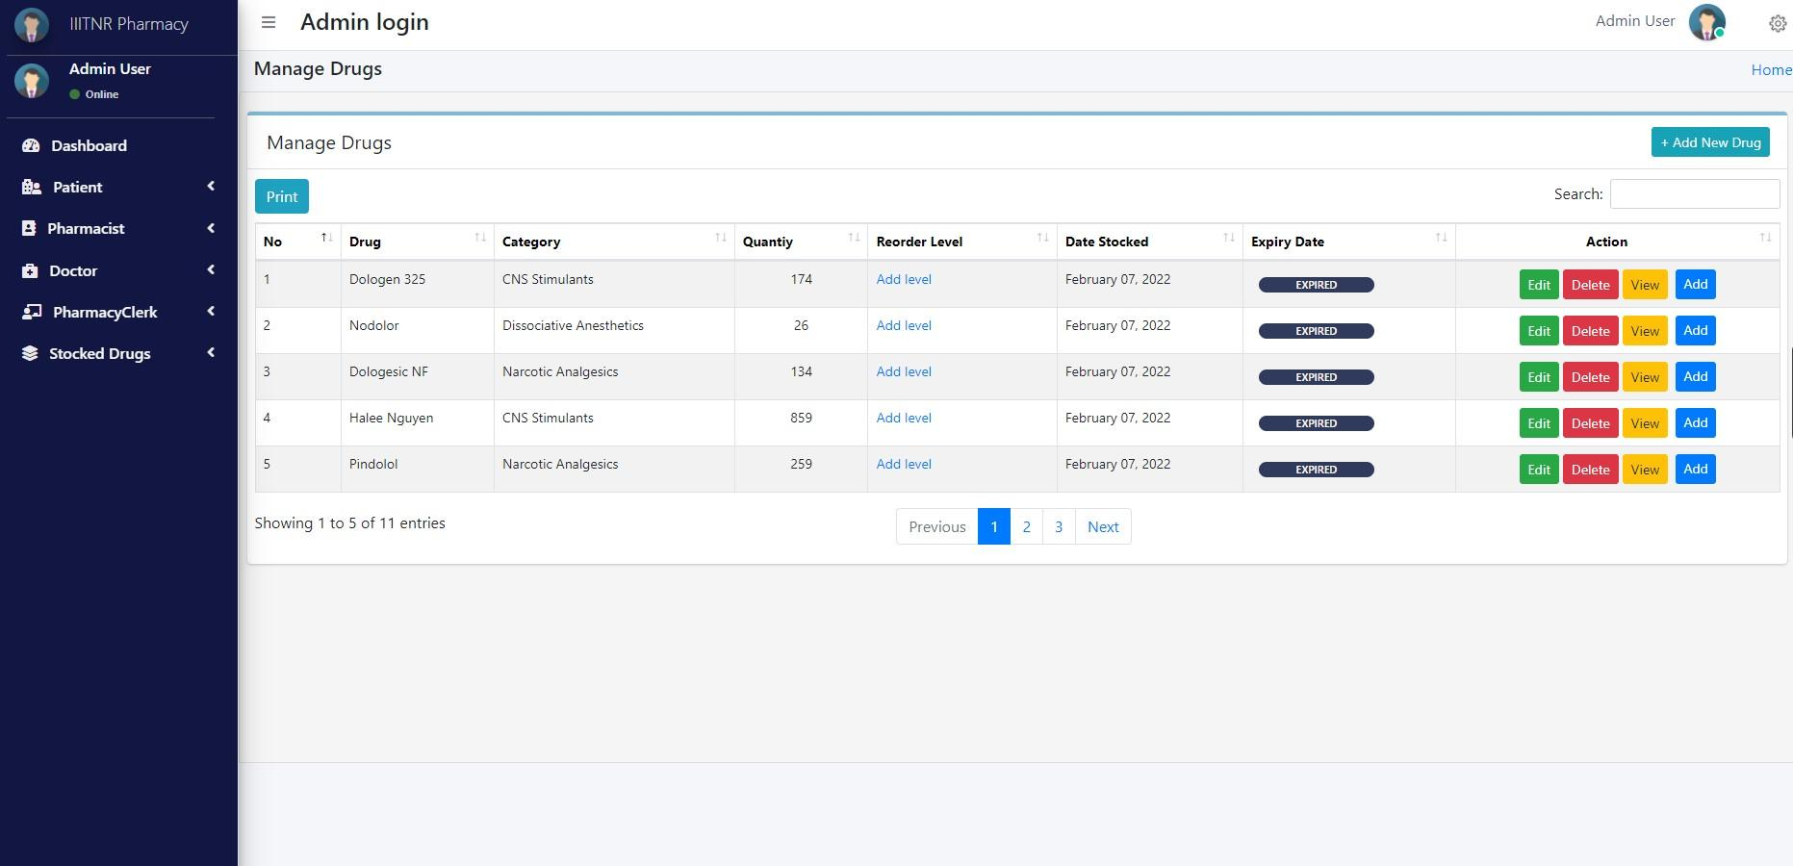

Fig. 6 Managing the stocks of the drugs with their expirations

The users can manage their personal accounts details and modify them as shown in Fig. 7.

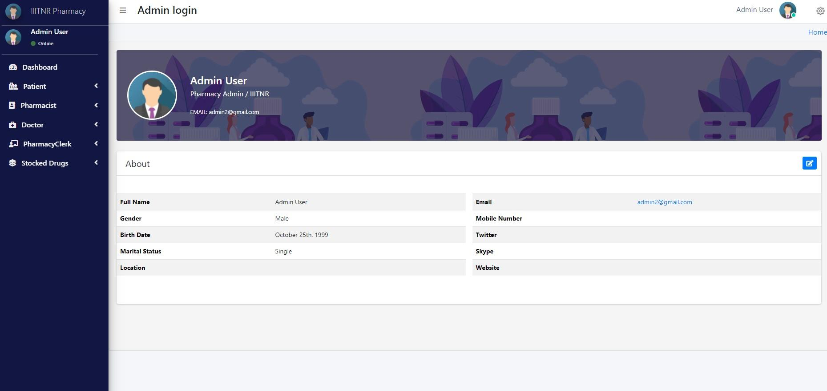

Fig. 7 Managing the Personal Accounts

The pharmacist has different functionalities like managing the drugs (expiration) and dispensing them to the patients. These functionalities are represented in Fig. 7 and Fig. 8.

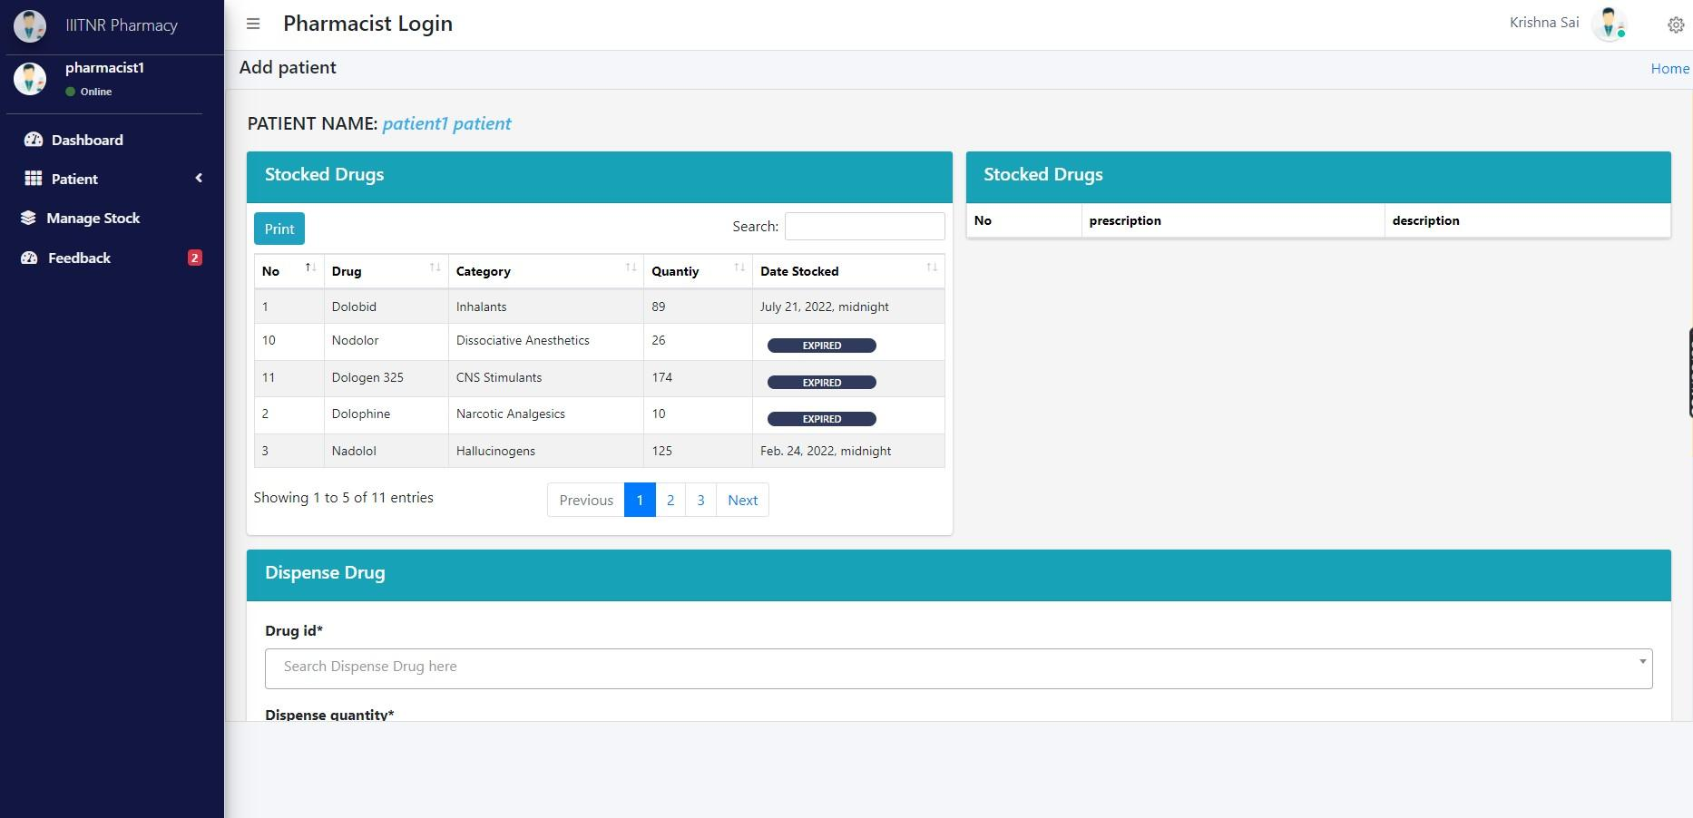

Fig. 8 Dispensing the drugs to patient by pharmacists

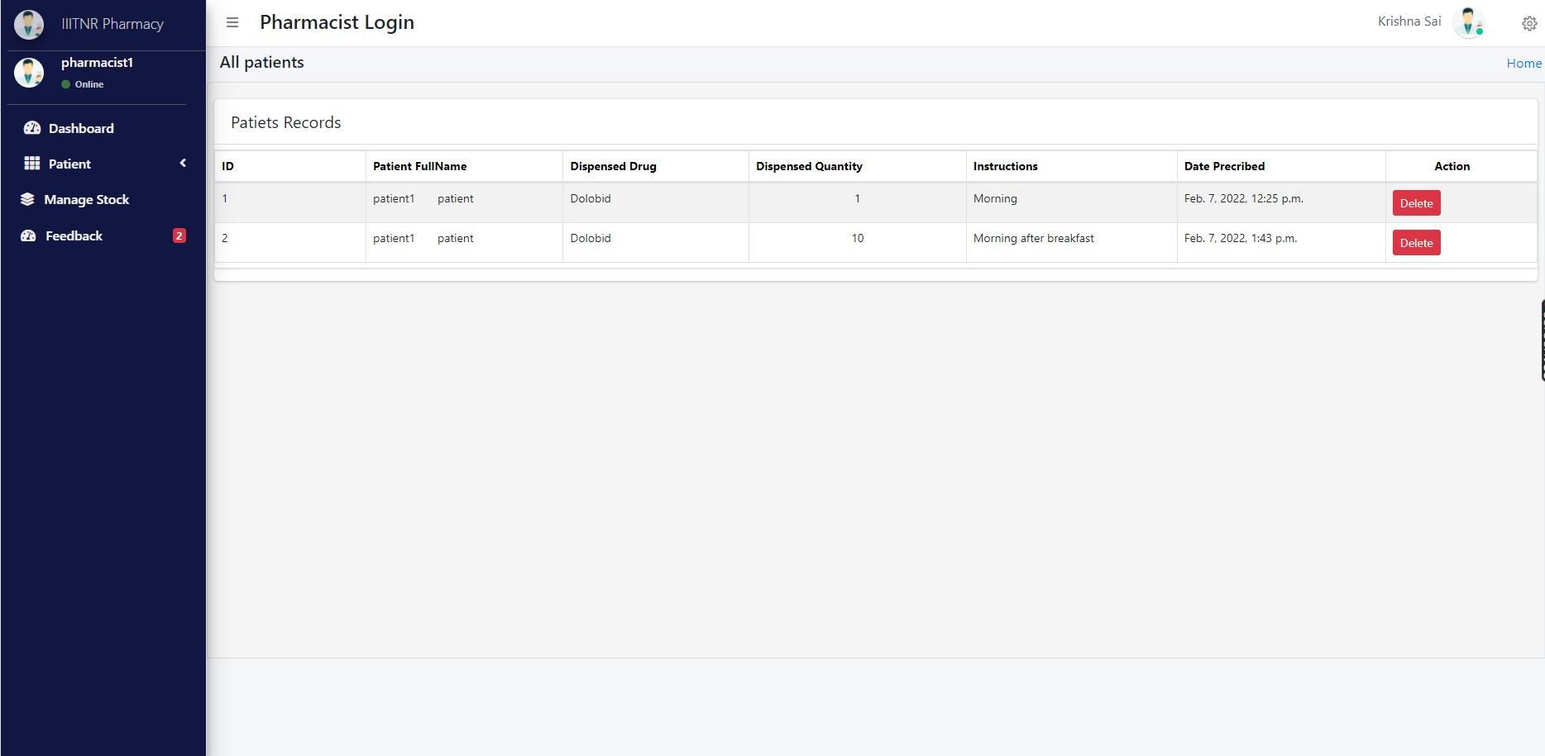

Fig. 9 Managing the records of dispenses given to the patient

Pharmacists can have a conversation with patients about the dispensed drug which is stored in the database ( in the feedback table) as shown in Fig. 9. Similarly, the patients, doctors and the clerk have different functionalities as explained in the proposed model as shown in Fig. 10.

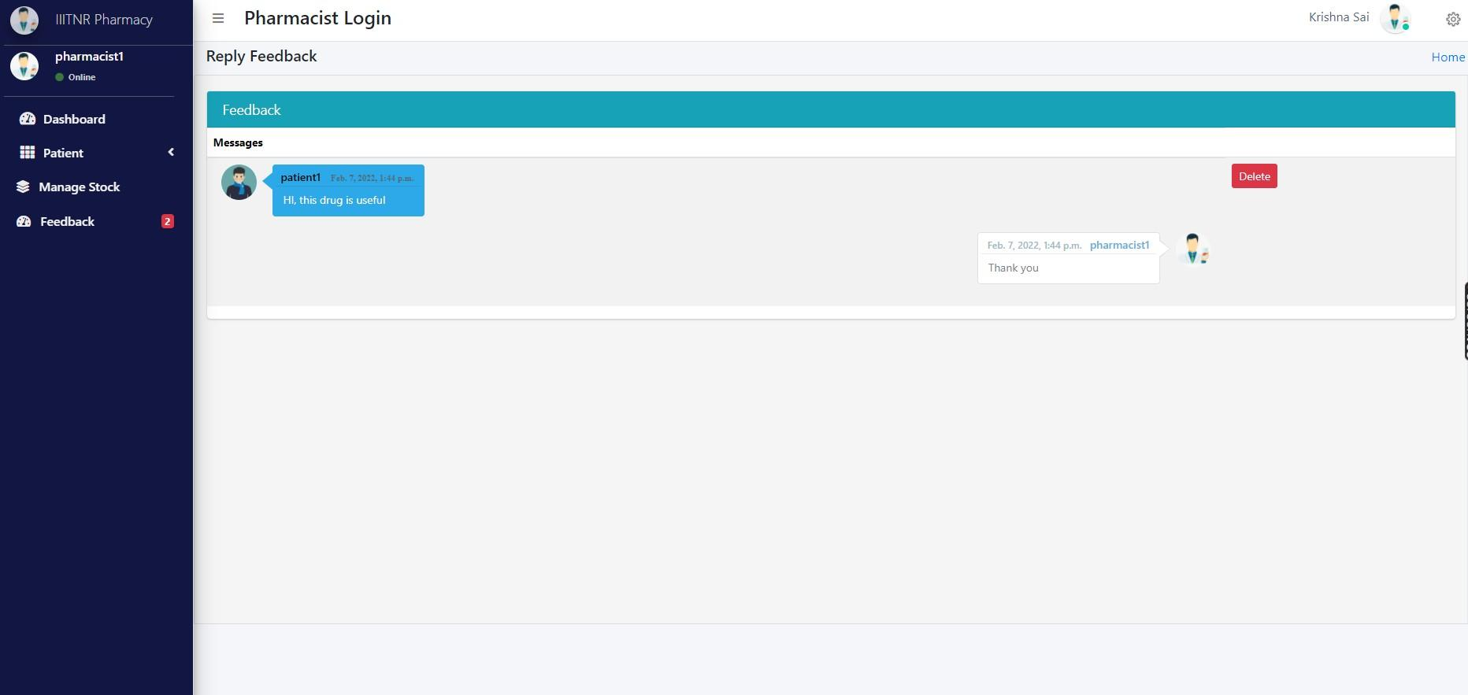

Fig. 10 Feedback chat between the patient and the pharmacist.



Fig. 11 Functionalities of the patient, doctor and clerk respectively.

Drugs, patients, doctors, pharmacists, clerks administration was also tested several times in several ways. The system also verifies the accuracy of the information obtained and the level of security obtained by presenting the user name and password in encrypted form.

**Applications of Project :**

This IIITNR pharmacy management software system can be used in any pharmacy that helps automate the pharmacy workflow. This includes such tasks as reviewing physician prescriptions and preparing medications, controlling the inventory and making drug orders, handling patients data, providing patient's dispenses , identifying incompatibilities, and more — all while following legal protocols and compliances. All the traditional functions that can be automated with good efficiency. Adding many features to existing systems gives the pharmacy a competitive edge by providing better customer experience and attracting patients with more personalized and engaging service.

* Improve the effectiveness of pharmacists.
* Improving patient health outcomes
* Drug Fraud Prevention
* Inventory clearance and counting

**Conclusion :**

The presented end-to-end system manages and controls all procedures related to the pharmacy. The presented system includes a database built using SQLite3 and a GUI design using Visual Studio and the Python Django Framework. The purpose of using the database is to present various advantages like reducing data redundancy; error updates, better consistency, great data Integrity and improved access to your data and improved data safety.

On the other hand, the GUI framework developed on the system so that various users based on their designations can interact with it. An unqualified person can operate the system. user. The presented system has undergone many tests with various perceptions. The results of this test showed superiority systems under study with fewer errors and more effective action.

The final conclusions are as follows:

* Built a user-friendly interface for various users.
* The system under study reduces human effort, human error and physical cost.
* The electronic pharmacy system improves accuracy, efficiency and speed compared to conventional ones. as a manual system.